Safety Report

Assessing and Advancing Safety Management in Aviation

Contents

SAFETY CULTURE 3

Maturity levels of the culture 3

safety management system (SMS) 4

1 - safety policy and objectives 4

2- safety and risk assessment 5

Risk assessment happens in four steps: 5

3 - Safety Assurance (SA) 8

4 - Safety Promotion 8

# SAFETY CULTURE

Safety culture is “the way people react to safety and risk when no one is watching”. It is an expression of how safety is viewed, valued and prioritized by management and employees in an organization.

# Maturity levels of the culture

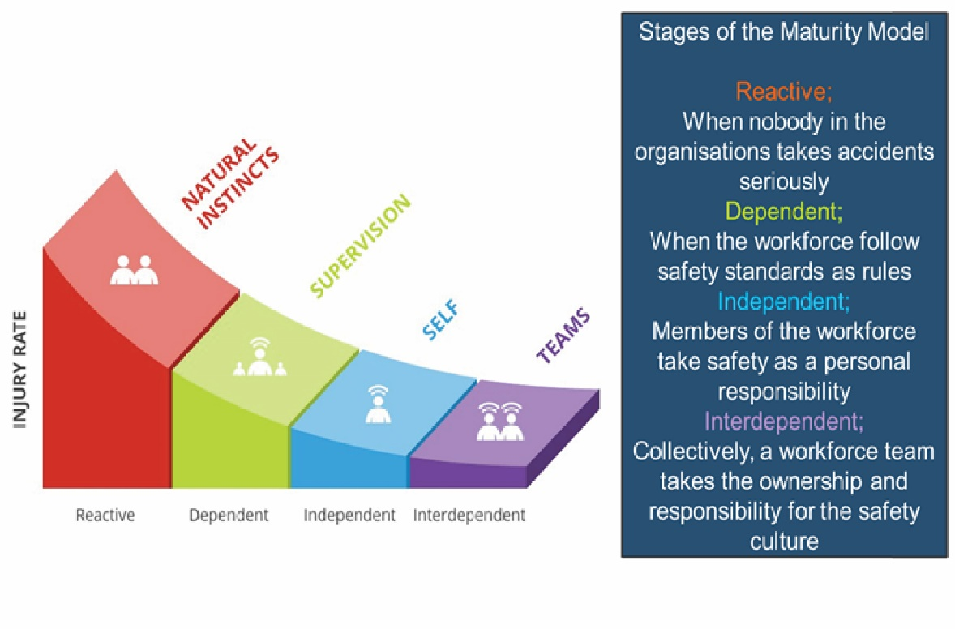

* **Reactive:** People do not take responsibility. They believe that safety is more a matter of luck and that accidents eventually happen.
* **Dependent:** people see safety as a matter of following regulations. Management believes that safety could be managed if only people would follow the rules.
* **Independent:** Individuals take responsibility for themselves. People who believe that safety is something personal.
* **Interdependent:** Teams of employees feel ownership for safety, and take responsibility for themselves and others. They believe true progress can only be achieved as a group, and that zero injuries is an achievable goal.

However, Only 14% of work sites operate from a helpful safety culture. So, for majority of organizations, unhelpful safety behaviors are common, leading to increased incidents and injuries.

So how is it that we can ensure that people are safer? How can we attain zero accidents and make sure that people are more interdependent?

*Using* ***Safety Management System***

# safety management system (SMS)

SMS is a program for promoting safety, is implemented by the employers to keep employees and the public safe in all operations. Effective safety management systems should prevent injuries, process failures, and improve the long-term profitability for the companies.

Aircraft operators and other aviation service provider organizations should establish and apply a formal [risk management](https://skybrary.aero/index.php/Risk_Management) process within the framework of the organizational SMS.

SMS has Four main Pillars:

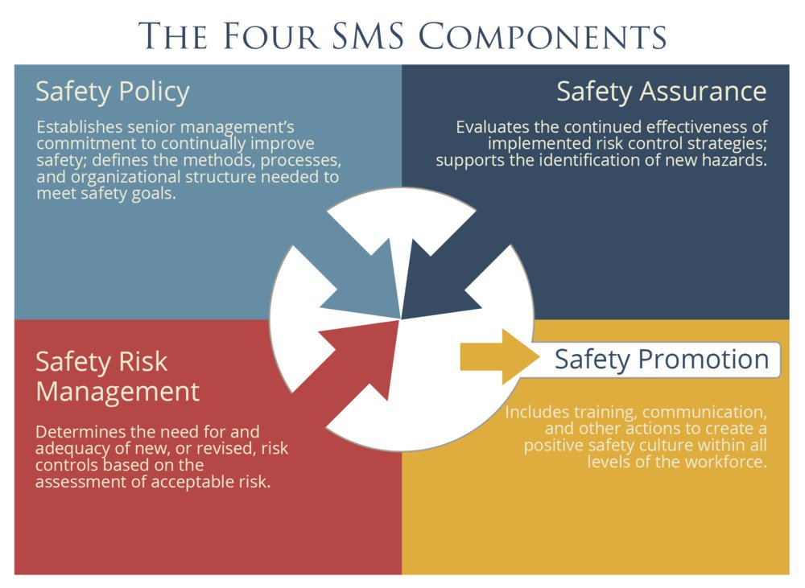

## 1 - safety policy and objectives

Safety policy and objective are establishing senior management's commitment to continually enhance safety; defines the ways, processes to meet safety goals, while trying to compromise -dilemma- between production and protection. The Safety Policy should also clearly define the roles and responsibilities within the organization. This includes the responsibility for reporting safety incidents.

Most aviation service providers identify the accountable executive that has ultimate accountability for the SMS. In some countries, the accountable executive risks financial penalties or jail time when an SMS is neglected. Element examples in aviation:

* Chief pilot.
* Director of maintenance.
* Account executive
* Safety manager.

## 2- safety and risk assessment

It is a process of determining and analyzing risks to assists with decision-making, and establish whether a safety risk is acceptable or not.

### Risk assessment happens in four steps:

1. Hazard Identification:

Identifying Hazards is locating deficient condition or an object with the potential to cause or contribute to an aircraft incident, injury, or death to people and/or system, equipment, or property damages or losses.

It is important to note that a hazard is any real or potential problem, including typical hazardous conditions related to human error such as time pressure, shift turnovers, and lack of system info.

The two main methodologies for identifying hazards are:

1. **Reactive.** This methodology involves analysis of previous events. Incidents and accidents are an indication of system deficiencies.
2. **Proactive**. This methodology involves collecting safety data of lower consequence events and analyzing the safety information if a hazard could lead to an accident or incident.
3. Risk analysis

After Determining potential damage, assess each risk and consider and predict how they are harmful and the possible outcomes. Estimation the potential impact and remember that a single hazard can have multiple consequences.

As noted above, risk analysis is only one step within the risk assessment process. The framework for risk analysis can be developed with the aid of potential impact estimates.

Risk assessment is mainly based on the evaluation of the following criteria: the severity of a hazard, the probability (frequency) of its occurrence.

1. **Severity of Hazards**

the extent of damage that might reasonably be expected to occur as a consequence of the identified hazard; for example, the impact on the safety of an aircraft and its occupants and other people who may be directly affected.

The severity of hazards will be determined by the credible effects on the safety of aircraft, when the outcome of all the weaknesses, potential failures and safeguards (barriers) which may exist in the relevant operational environment have been taken into account.

1. **Probability of Occurrence**

A prediction of the frequency of the hazard occurring or in other words forcasting the interval of exposure in which a hazard effect may manifest itself. Safety risk probability is the likelihood that a safety consequence or outcome will occur.

Both probability of occurrence and the severity potential of that effect, are vitality needed to be taken into account when deciding on the tolerability (acceptability) of a risk.

1. Safety risk tolerability

Deciding if the risk is tolerable or intolerable. If yes, the SRM (safety & risk management) component of SMS is complete and [the risk moves to the next component](https://safetyculture.com/topics/safety-management-system/#SMS-Component-3-Safety-Assurance) for monitoring. Otherwise, risk controls should be put into action. It is a common to use a **risk assessment matrix (RAM)** to support in this two-dimensional judgement.

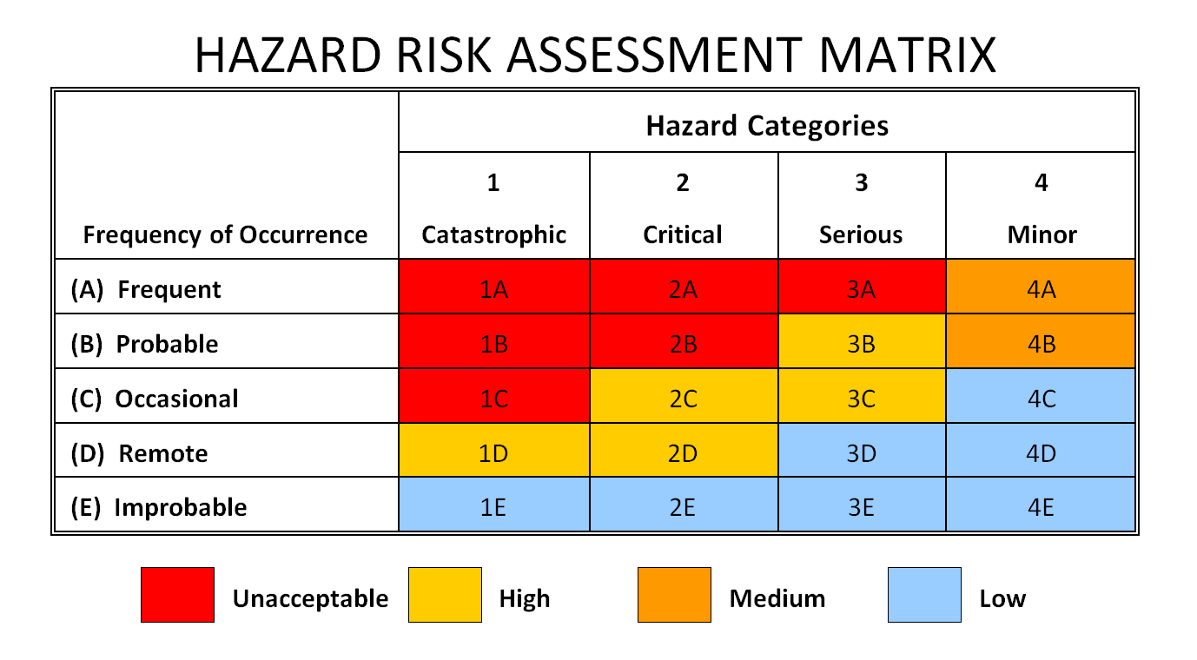

* **Acceptable** means that no further action needs to be taken, unless the risk can be reduced further at minimum cost or effort.
* **Tolerable** means that the affected persons are prepared to live with the risk in order to have certain benefits, in the understanding that the risk can be handled and is being mitigated as best as possible.
* **Unacceptable** means that operations under the current conditions must cease until the risk is dealt with and dwindled to at least the tolerable level.

1. Implement Risk Control

It is the risk mitigation by formulating an actions plan. The process of incorporating defenses, preventive controls or recovery safety measures to safeguard people, property, or the environment.

While the severity of risks may be lessened to a certain degree, decreasing their probability or likelihood is what happens in most situations. You are not expected to eliminate all risks since this is impossible. You do, however, want to take measures appropriate to the level of risk.

Other things that could be taken into consideration in risk assessment:

|  |  |
| --- | --- |
| 2.1 | Identification of hazards and disturbances |
| 2.2 | Risk assessment for design and change |
| 2.3 | Safety risk control |
| 2.4 | Fatigue risk management |
| 2.5 | Sufficiency of resources |
| 2.6 | Maintenance |

## 3 - Safety Assurance (SA)

SA is the component of safety management system that deals with the monitoring of risk controls during operations. After strategically placing control measures, their performance and effectiveness should be tested as well. Upon gathering all necessary information, they should be analyzed against set objectives and compared with existing norms for patterns. Oftentimes, safety risk controls fail due to lack of leadership, resources, and instruction

Common SA functions Particularly in aviation, operational data sources such as flight dispatch records, crew schedules, and aircraft discrepancy reports prove to be useful for the continuous monitoring of safety risk controls.

## Slips, Trips & Falls - SafeMT.com4 - Safety Promotion

Safety Promotion is to sustain and develop aviation safety through raising awareness and changing behaviors. Safety promotion includes reports and technical publications, leaflets and posters, toolkits, manuals and guides.

To promote safety as a company core value, employees should learn from shared experience through [training](https://www.edapp.com/), knowledge-sharing, and communication. Management should also highlight why such particular actions are taken in order to consistently foster an environment for open reporting of safety concerns.

References

*Risk Assessment | SKYbrary Aviation Safety*. (n.d.). https://skybrary.aero/articles/risk-assessment

Stroeve, S. H., Smeltink, J. W., & Kirwan, B. (2022). Assessing and Advancing Safety Management in Aviation. *Safety*, *8*(2), 20. https://doi.org/10.3390/safety8020020

SafetyCulture. (2023, March 27). *What is Safety Management System (SMS)? | SafetyCulture*. https://safetyculture.com/topics/safety-management-system/

Howell, C. (2022, July 28). *Five Elements of ICAO’s Safety Policy and Objectives in SMS*. https://aviationsafetyblog.asms-pro.com/blog/the-five-elements-of-icaos-safety-policy-and-objectives-in-sms

*Understanding Safety Culture Maturity - Sentis*. (n.d.). Sentis. https://sentis.com.au/articles/sentis-safety-culture-maturity-model#:~:text=Mature%20safety%20cultures%20are%20more%20conducive%20to%20good,benefit%20of%20themselves%2C%20their%20team%20and%20the%20organisation.

*Safety Management Basic Concepts*. (n.d.). www.icao.int. https://www.icao.int/NACC/Documents/Meetings/2019/SMSANSP/SMSxANSP-P01.pdf